EXPERIMENT 1
Simulation-Based Electromagnetic Analysis of TEM, TE and TM Propagation Modes in Microwave Transmission Structures
OBJECTIVE 1:
To develop electromagnetic simulation models for TEM, TE and TM propagation modes in suitable microwave transmission structures.
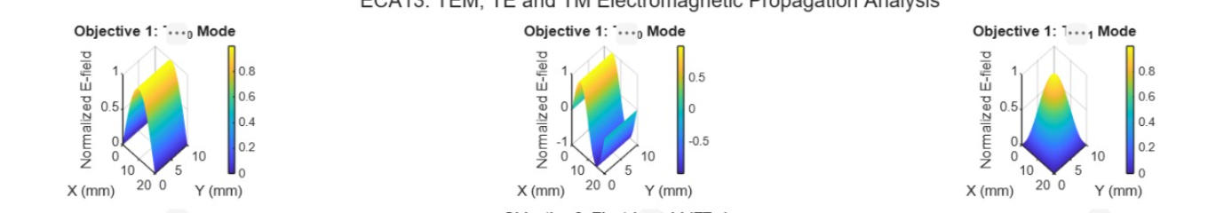
OBJECTIVE 2:
To visualize and analyze the electric-field and magnetic-field distributions associated with different propagation modes.
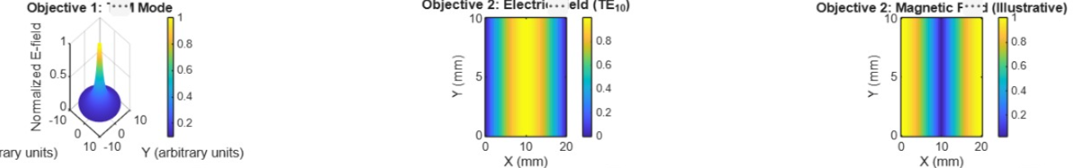
OBJECTIVE 3.
To determine the cutoff frequency, propagation constant and field characteristics of selected TE and TM modes.
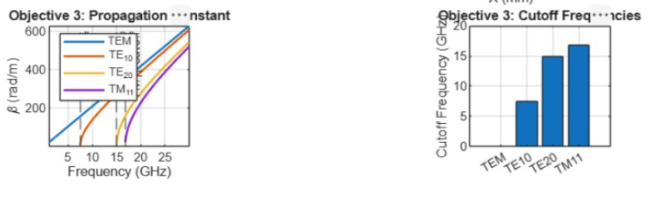
OBJECTIVE 4.
To compare the propagation behavior of different modes and identify their suitability for practical microwave transmission.
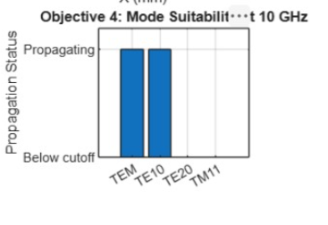
OUTPUT:
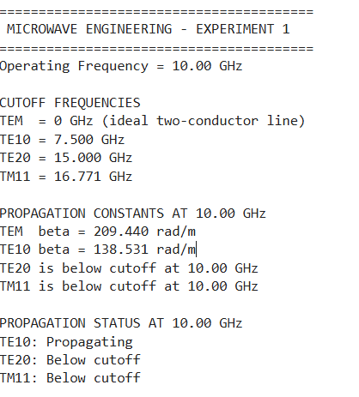
RESULT:
The MATLAB simulation successfully analyzed the TEM, TE₁₀, and TM₁₁ propagation modes. The 3D surface plots displayed their electric-field distributions, while the comparison graphs illustrated the cutoff frequencies and propagation constants. At the operating frequency of 10 GHz, the TE₁₀ mode propagates because the operating frequency exceeds its cutoff frequency of 6.562 GHz, whereas the TM₁₁ mode does not propagate because its cutoff frequency is 16.156 GHz. The simulation demonstrates how propagation characteristics depend on frequency and waveguide dimensions.

